**Name: Goh Fang Yao (270654)**

**Quiz 2**

**Questions:**

**1. What will be the output when running the above code?**

Meow. I am a cat. My name is Kurre.

Woof. I am a dog. My name is Vilma.

Meow. I am a cat. My name is Kurre.

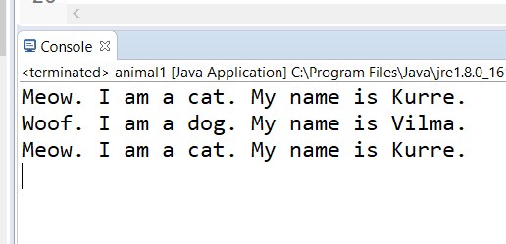

**2**. **What is meant by polymorphism ?**

Polymorphism is the ability of an object to take on many forms. The most common use of polymorphism in OOP occurs when a parent class reference is used to refer to a child class object.

**3. How does polymorphism work in the above program?**

We have a class Animal that has a method introduceYourself().

Then we have two subclasses of Animal class which is Cat and Dog that extends Animal class.

**4. The method introduceYourself of Animal appears to be never called? Why not?**

It never calls on the instance of the class. It always called on class.

[Polymorphism](http://docs.oracle.com/javase/tutorial/java/IandI/polymorphism.html) comes into picture when we [override](http://docs.oracle.com/javase/tutorial/java/IandI/override.html) the method in subclass. since static method belong to class hence there is no meaning of overriding static methods. Hence Polymorphism always works for instance methods only that belongs to the instances of the class.

**5. Comment out the method introduceYourself in Dog. What happens now when you run the program?**

“My name is Vilma” disappear for Dog

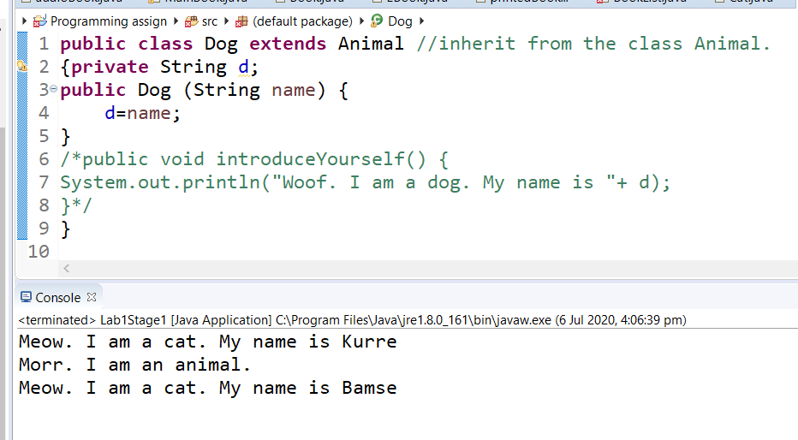

**6. Where is the name stored for the instances of Cat and Dog? (In what / which classes did you put the instance variable that refers to the name of the animal? Both Cat and Dog, or just in Animal?)**

I put the instance variable that refers to the name of the animal in both Cat and Dog subclasses, so both Cat and Dog subclasses can inherit it.

**7. How does the code in the test program work?**

We have a class Animal that has a method introduceYourself().

Then we have two subclasses of Animal class which is Cat and Dog that extends Animal class.

**8. How does an array work?**

If you use the subclass from an array that contains its superclass, then you have access only to the methods that are available in the superclass, as these are the methods common among all subclasses.

**9. In the above programs we have used a while loop to step through the array and to get information about the animals. But there is a more appropriate loop statement here. What is it?**

By using a for loop, to reduce the length of the code and avoid using additional variables.